**VIVEKANAND EDUCATION SOCIETY’S INSTITUTE OF TECHNOLOGY**

**An Autonomous Institute Affiliated to University of Mumbai**

**Department of Computer Engineering**



Project Report on

Wireless Data Extraction Using YOLO Model

In partial fulfillment of the Fourth Year, Bachelor of Engineering (B.E.) Degree in Computer Engineering at the University of Mumbai

Academic Year 2023-24

**Submitted by**

Prathamesh Thakur-D17A- 68

Hariharan Iyer-D17A -23

Shreyas Sawant-D17A- 59

Tanisha Patil-D17A- 54

**Project Mentor**

Prof. Priya R L

(2023-24)

**VIVEKANAND EDUCATION SOCIETY’S INSTITUTE OF TECHNOLOGY**

**An Autonomous Institute Affiliated to University of Mumbai**

**Department of Computer Engineering**



**Certificate**

This is to certify that **Hariharan Iyer(D17A, 23), Prathamesh Thakur(D17A, ), Shreyas Sawant (D17A, ), Tanisha Patil (D17A, *)*** of Fourth Year Computer Engineering studying under the University of Mumbai have satisfactorily completed the project on “**Wireless Data Extraction Using YOLO Model**” as a part of their coursework of PROJECT-II for Semester-VIII under the guidance of their mentor **Prof. Priya R L** in the year 2023-24 .

This project report entitled Wireless Data Extraction Using YOLO Model by **Hariharan Iyer, Prathamesh Thakur, Shreyas Sawant , Tanisha Patil** is approved for the degree of **B.E. Computer Engineering.**

| Programme Outcomes | Grade |
| --- | --- |
| PO1,PO2,PO3,PO4,PO5,PO6,PO7,  PO8, PO9, PO10, PO11, PO12  PSO1, PSO2 |  |

Date:

Project Guide:

------------------------------------------



Date: 05/8/2023

**Letter of Permission**

This is to certify that following Final year students of Department of Computer Engineering of Vivekanand Education Society’s Institute of Technology, Chembur, are working on a TIFR project titled “**Wireless extraction of Display Panel System**”,under the guidance of **Mrs. Priya R.L** and **Mrs. Sunita Suralkar** for the academic year 2023-24.

**1. Prathamesh Thakur**

**2. Shreyas Sawant**

**3. Hariharan Iyer**

**4. Tanisha Patil**

We will provide all technical assistance to students required during the completion of the project. The progress seminars and meetings will be regularly conducted to take feedback.



Dr. Shashikant Dugad,

Professor, Department of High energy Physics,

Tata Institute of Fundamental Research, Mumbai.

**Project Report Approval**

**For**

**B. E (Computer Engineering)**

This project report entitled **Wireless Extraction Of data using YOLO** by **Hariharan Iyer, Prathamesh Thakur, Shreyas Sawant , Tanisha Patil** is approved for the degree of **B.E. Computer Engineering.**

Internal Examiner

---------------------------------------------

External Examiner

---------------------------------------------

Head of the Department

-----------------------------------------------

Principal

-----------------------------------------------

Date:

Place: Mumbai

**Declaration**

We declare that this written submission represents our ideas in our own words and where others' ideas or words have been included, we have adequately cited and referenced the original sources. We also declare that we have adhered to all principles of academic honesty and integrity and have not misrepresented or fabricated or falsified any idea/data/fact/source in our submission. We understand that any violation of the above will be cause for disciplinary action by the Institute and can also evoke penal action from the sources which have thus not been properly cited or from whom proper permission has not been taken when needed.

-----------------------------------------

Hariharan Iyer

-----------------------------------------

Prathamesh Thakur

-----------------------------------------

Shreyas Sawant

----------------------------------------

Tanisha Patil

**ACKNOWLEDGEMENT**

We are thankful to our college Vivekanand Education Society’s Institute of Technology for considering our project and extending help at all stages needed during our work of collecting information regarding the project.

It gives us immense pleasure to express our deep and sincere gratitude to Assistant Professor **Prof. Priya R L** (Project Guide) for her kind help and valuable advice during the development of project synopsis and for her guidance and suggestions.

We are deeply indebted to Head of the Computer Department **Dr. (Mrs.) Nupur Giri** and our Principal **Dr. (Mrs.) J. M. Nair ,** for giving us this valuable opportunity to do this project.

We express our hearty thanks to them for their assistance without which it would have been difficult in finishing this project synopsis and project review successfully.

We convey our deep sense of gratitude to all teaching and non-teaching staff for their constant encouragement, support and selfless help throughout the project work. It is a great pleasure to acknowledge the help and suggestion, which we received from the Department of Computer Engineering.

We wish to express our profound thanks to all those who helped us in gathering information about the project. Our families too have provided moral support and encouragement several times.

**Computer Engineering Department**

**COURSE OUTCOMES FOR B.E PROJECT**

Learners will be to,

| **Course**  **Outcome** | **Description of the Course Outcome** |
| --- | --- |
| CO 1 | Able to apply the relevant engineering concepts, knowledge and skills towards the project. |
| CO2 | Able to identify, formulate and interpret the various relevant research papers and to determine the problem. |
| CO 3 | Able to apply the engineering concepts towards designing solutions for the problem. |
| CO 4 | Able to interpret the data and datasets to be utilised. |
| CO 5 | Able to create, select and apply appropriate technologies, techniques, resources and tools for the project. |
| CO 6  CO 7  CO 8 | Able to apply ethical, professional policies and principles towards societal, environmental, safety and cultural benefit.  Able to function effectively as an individual, and as a member of a team, allocating roles with clear lines of responsibility and accountability.  Able to write effective reports, design documents and make effective presentations. |
| CO 9 | Able to apply engineering and management principles to the project as a team member. |
| CO 10 | Able to apply the project domain knowledge to sharpen one’s competency. |
| CO 11 | Able to develop a professional, presentational, balanced and structured approach towards project development. |
| CO 12 | Able to adopt skills, languages, environment and platforms for creating innovative solutions for the project. |

**List of figures**1. Block diagram of the Proposed system for live video streaming  
2. Block diagram of the Proposed system for pre recorded video  
3. Modular Diagram  
4. Gantt chart  
5. Error on Arduino  
6. Screenshot for Login page  
7. Screenshot for Register page  
8. Enter a new rtsp stream link   
9. Home page where user can upload a video from local system or connect to an existing ip camera link   
10. Detecting numbers  
11. ESP32 Cam module  
12. Hardware setup

13. Email notification sent to the logged in email on a value beyond set threshold  
  
**List of tables**1. Table of comparison  
2. Workflow table

**Index**

| **Chapter No.** | **Title** | **Page No.** |
| --- | --- | --- |
| 1 | **Introduction**  1.1 Introduction  1.2 Motivation  1.3 Problem Definition  1.4 Relevance of the Project  1.5 Methodology used | 11-13 |
| 2 | **Literature Survey**  2.1 Research Papers referred  2.2 Books/ Journals/ Articles referred  2.3 Patent search  2.4 Existing Systems  2.5 Lacuna in the existing systems  2.6 Comparison of existing systems and proposed area of work  2.7 Focus Area | 14-21 |
| 3 | **Requirements of Proposed System**  3.1 Proposed model  3.2 Functional Requirements  3.3.Non-Functional Requirements  3.4.Hardware & Software Requirements  3.5.Technology and Tools utilized  3.6.Constraints of working | 22-23 |
| 4 | **Proposed Design**  4.1 Block Diagram of the proposed system  4.2 Modular diagram  4.3. Project Scheduling & Tracking using Timeline / Gantt Chart | 24-28 |
| 5 | **Implementation of proposed system** | 29 |
| 6 | **Testing of the Proposed System** | 30-32 |
| 7 | **Results and Discussion** | 33-37 |
| 8 | **Conclusions** | 38 |
| 9 | **References** | 39-40 |
| 10 | **Appendix** | 41 |

**Abstract**

The gathering, storing, and analysis of data have undergone a paradigm change with the introduction of the Internet of Things (IoT). The collecting of enormous volumes of data from several sources has been made possible by the exponential proliferation of networked devices and sensors. IoT and AI integration has emerged as a revolutionary force with the ability to revolutionize society and improve human existence in order to fully utilize this data-rich environment. However, there are several difficulties in using IoT data, especially in industrial and research contexts. Real-time and streaming data extraction from complicated contexts is notoriously challenging. Additionally, connecting to IT-based data collection networks and guaranteeing the security of these data streams can be challenging jobs that call for careful planning.This project's main goal is to overcome these issues by proposing a non-intrusive, wireless method for extracting display panel data. The project intends to provide seamless data collecting from display panels through the use of AI algorithms, enabling real-time monitoring and analysis of crucial data. The system's accessibility and scalability are further improved by the inclusion of IoT-capable devices.

The research uses the YOLO (You Only Look Once) algorithm, a neural network-based technique recognised for its amazing speed and precision, to produce effective and precise object recognition. YOLO has found use in a variety of fields, from word, character, and number detection to the recognition of people, traffic signs, parking meters, and animals.character, and number detection.

By carefully designing and implementing secure communication protocols, which guarantee that data integrity and confidentiality are preserved, the security issues surrounding data collection networks are solved.

**Chapter 1: Introduction**

**1. Introduction**

**1.1 Introduction**

In recent times data has taken on the role as the lifeblood of innovation and advancement in the linked world of today. This data-driven revolution has been accelerated by the Internet of Things (IoT), which connects an ever-growing network of machines, gadgets, and sensors. This enormous network of connectivity produces a tremendous amount of real-time data, providing priceless insights into a variety of fields, from industrial operations to research applications.Nevertheless, even with the abundance of data made possible by IoT, retrieving and analyzing it in streaming and real-time settings continues to be quite difficult, especially in complicated contexts. Unique data gathering challenges are frequently present in industrial settings and research datasets, creating barriers to quick and accurate access to vital information.

The main goal of this research is to overcome these difficulties by offering a novel, non-intrusive, and wireless method of data extraction from display panels. This system seeks to deliver seamless real-time data collecting and monitoring from display panels in diverse settings by utilizing cutting-edge AI algorithms. This would greatly improve operational efficiency and decision-making processes.This project's foundation is the well-known YOLO (You Only Look Once) algorithm. Due to its outstanding speed and accuracy while performing real-time object identification, this potent AI-based method has become quite popular. The project aims to provide the system the capacity to recognise letters, characters, and numbers on display panels by incorporating YOLO into it.

The YOLO model has been effectively used in a number of applications, including identifying traffic signals, detecting objects, and identifying animals, demonstrating its adaptability beyond textual recognition. It excels in Optical Character Recognition (OCR) jobs and outperforms other OCR models in terms of speed and efficiency because to its exceptional performance and lightweight design.This research marks a critical milestone in the fusion of IoT and AI technologies with the potential to upend conventional data collecting techniques and revolutionize businesses everywhere. This project's results and innovations might have an influence on a variety of industries, including manufacturing, research, transportation, and healthcare, and could usher in a new era of data-driven intelligence and connectedness.

**1.2 Motivation**

There are several motivations for capturing machine readings using ESP32 and YOLO models.

ESP32 is a low-cost, low-power microcontroller that is well-suited for embedded applications. It has a dual-core processor, Bluetooth and Wi-Fi connectivity, and a variety of I/O pins. This makes it a good choice for building machine vision systems that need to be portable and battery-powered.

YOLO (You Only Look Once) is a real-time object detection model that is known for its accuracy and speed. It can detect multiple objects in a single image in real time, making it ideal for machine vision systems that need to track objects or monitor their environment.

Combining ESP32 and YOLO makes it possible to build low-cost, low-power machine vision systems that can be used in a variety of applications. For example, such a system could be used to:

* Monitor a production line for defects
* Track the movement of people or vehicles in a busy area
* Detect objects in a surveillance camera feed
* Identify and classify objects in a warehouse

**1.3 Problem Definition**

* This project addresses the core issue of extracting data from display panels in a real-time and wireless manner, challenging conventional, invasive methods and security concerns in IT-based data acquisition networks.
* It aims to overcome key challenges, including achieving non-invasive, real-time, and accurate data extraction, integrating IoT and AI for intelligent data handling, incorporating YOLO for robust OCR, ensuring data security and connectivity, and designing a system with usability and scalability.
* The project's success promises a transformative data acquisition and analysis system, enhancing decision-making, operational efficiency, and security across various industries and research fields.

**1.4 Relevance of Project**

Attaching an extra circuit for capturing digital readings is not feasible and also the systems may need continuous updates from time to time, having an external system to record the readings ensures accuracy and is fool proof.

Also ESP32 is a small and lightweight microcontroller, making it ideal for building portable machine vision systems.

**1.5 Methodology Used**

1. The video feed is taken using ESP-32 camera module and also mobile camera

So basically the application is flexible and will show the stream captured from mobile or esp 32 camera as long as the device is connected in the same network.

1. The camera is pointed towards the display panel.

One main requirement is that the camera must always be facing the display panel for accurate capture.

1. Divide the video into frames and annotate the model using makesense.ai tool.

Here the video is divided into frames so as to make training possible i.e. training here means to annotate the digits from display panel to text.

1. Divide the annotated files into training and validation datasets.

As mentioned above this part determines the training and testing sets.

1. Train the YOLO model on the training images.

Based on the frame set the model will be trained

1. For testing, live camera feed can be used or a video from the local file system can also be uploaded.

Finally we will test the model by streaming from either a live source or an existing feed.

**Chapter 2: Literature Survey**

**A.Overview of literature survey:**

The papers discussed here focus on various job recommendation skills as well as different skills and job portals. These papers are studied to understand how the skills and jobs are dependent on each other. The studies examine how to create the job recommendation system more efficiently. Overall, the papers highlight the importance of taking a comprehensive approach to address how these above factors can be used and enhanced for the development of a complete system which can provide both the courses as well as jobs.

**2.1. Research Papers :   
1. Real Time Object Detection System with YOLO and CNN Models: A Review (2022)  
Methodology:** Review of YOLO and CNN models for object detection  
**Performance measures:** Accuracy, speed, and generalization ability  
**Inference:** YOLO's speed makes it a strong candidate for real-time applications where immediate response is critical. For instance, in autonomous vehicles, YOLO can swiftly detect pedestrians and obstacles, enabling quick evasive maneuvers. Similarly, in video surveillance, real-time object detection allows for immediate identification of suspicious activity. Furthermore, YOLO's ability to learn generalizable object representations suggests it can adapt to new environments and unseen objects to some degree. This can be advantageous for real-world scenarios where encountering entirely novel objects is a possibility. **Limitations:** While YOLO excels at speed, its accuracy might suffer when dealing with small objects or scenes with numerous overlapping objects. These situations can lead to missed detections or inaccurate bounding boxes. Additionally, compared to some CNN-based detectors, YOLO might require a larger dataset for training to achieve optimal performance. This can be a hurdle for applications with limited or specialized data.

**2. A Comparative study of yolo and SSD Detection object algorithms (2021)  
Methodology:** Comparison of SSD and YOLOv3 object detection algorithms  
**Performance measures:** Speed, accuracy, real-time video analysis capabilities  
**Inference:** For applications demanding real-time processing, like traffic monitoring where immediate analysis of video feeds is crucial, SSD's prioritization of speed makes it the preferred choice. By swiftly detecting and classifying vehicles, SSD can provide valuable data for traffic management systems, such as congestion alerts or adaptive traffic light control. However, YOLOv3's superior accuracy makes it more suitable for tasks requiring high precision, such as medical image analysis. In medical scenarios, accurate identification of tumors or other abnormalities is paramount, and YOLOv3's ability to provide detailed and precise bounding boxes can be critical for diagnosis and treatment planning. **Limitations**:SSD's focus on speed comes at the cost of some accuracy, especially for complex objects or cluttered environments. For instance, differentiating between different types of birds in a crowded bird feeder might be challenging for SSD due to its prioritization of fast processing. Similarly, YOLOv3, while more accurate, might not be ideal for resource-constrained devices due to its higher computational cost. Running YOLOv3 on low-powered devices like smartphones might drain battery life quickly or cause lags in processing.

**3. Computer-Vision Based Object Detection and Recognition for Service Robot in Indoor Environment (2021)  
Methodology:**Proposed algorithm for real-time object detection and localization using an RGB-D camera  
**Performance measures:** Accuracy, speed, real-time performance  
**Inference:** The proposed algorithm empowers service robots to navigate safely and efficiently in indoor environments by enabling real-time object detection and localization. This allows robots to identify and avoid obstacles, locate specific objects for manipulation (e.g., picking up packages), and plan their movements accordingly. This capability is crucial for tasks like delivering packages in office buildings or cleaning floors in hospitals. The real-time nature of the algorithm ensures robots can react promptly to changes in the environment, further enhancing their safety and performance.  
**Limitations:**The algorithm's performance might be hindered by poor lighting conditions. In dimly lit environments, the camera might struggle to capture clear images, impacting the accuracy of object detection. Additionally, the algorithm might not be able to recognize objects not included in the training data. For instance, encountering a new type of mop or cleaning cart in a hospital might lead to confusion for the robot. Furthermore, the effectiveness of the algorithm might be dependent on the specific RGB-D camera used. Different cameras have varying capabilities in terms of depth perception and image resolution, which can impact the quality of the data and ultimately the performance of the algorithm.  
  
**4. Smart Health Monitoring System using IOT and Machine Learning Techniques (2020)  
Methodology:**Proposed system for early disease detection using IoT devices and machine learning techniques  
**Performance measures:** Accuracy, early detection capabilities  
**Inference:** Early disease detection is a cornerstone of preventative healthcare. By continuously monitoring vital signs and other health data using IoT devices, this system can identify subtle changes that might indicate potential health issues. These anomalies can then be flagged for further investigation by medical professionals. For instance, the system might detect a gradual rise in blood pressure over time, prompting a doctor to recommend lifestyle changes or medication to prevent future complications. Early detection of diseases like heart disease or diabetes can significantly improve patient outcomes and quality of life. Furthermore, the system can empower individuals to take a more proactive role in managing their health by providing them with real-time insights into their physiological data.  
**Limitations**:The accuracy of the system heavily relies on the quality and quantity of data used to train the machine learning models. Inaccurate or insufficient data can lead to false positives (flagging healthy individuals as having potential issues) or false negatives (missing actual health anomalies). Additionally, the system might struggle with rare diseases or individual variations in health patterns. For instance, an individual with naturally low blood pressure might trigger an anomaly alert. Privacy concerns around user data also need to be addressed. Ensuring the security and confidentiality of sensitive health information is paramount.  
  
**5. Edge Computing-Enabled Wireless Sensor Networks for Multiple Data Collection Tasks in Smart Agriculture (2020)  
Methodology:** Proposed strategy for multiple data collection tasks in WSNs using edge computing  
**Performance measures:** Data quality, low latency  
**Inference:** In smart agriculture, timely access to accurate data is crucial for optimizing crop yields and resource management. Traditional Wireless Sensor Networks (WSNs) can suffer from data latency and quality issues, especially when dealing with multiple data collection tasks. The proposed strategy addresses these challenges by leveraging edge computing. By processing data closer to the source (i.e., on sensors or local gateways), edge computing reduces latency and improves data quality. This allows farmers to receive real-time insights into factors like soil moisture, temperature, and nutrient levels. With this information, they can make informed decisions about irrigation, fertilization, and other agricultural practices, ultimately leading to improved crop yields and resource utilization.  
**Limitations:** Implementing edge computing requires additional hardware and software infrastructure, which can increase costs for farmers. The effectiveness of the strategy might also be impacted by factors like network bandwidth and sensor reliability. Limited bandwidth can lead to data bottlenecks, while unreliable sensors can provide inaccurate data, ultimately hindering the system's performance.

**6. Object Detection through Modified YOLO Neural Network (2020)**  
**Methodology:** Proposed modifications to the YOLOv1 neural network for object detection  
**Performance measures:** Accuracy, speed  
**Inference:** The paper highlights the potential for improving existing object detection models through targeted modifications. The proposed modifications to the YOLOv1 network significantly enhance its accuracy, making it competitive with other detectors like R-CNN. This demonstrates the ability to fine-tune existing models to address specific limitations. For instance, the modifications might have focused on improving YOLOv1's ability to detect small objects, a known challenge for the original model. This enhanced accuracy can be beneficial in various applications, such as self-driving cars where precise object detection is critical for safe navigation. **Limitations:**The paper doesn't specify the exact modifications made to the YOLOv1 network. Without this information, it's difficult to assess the generalizability of the approach or potential trade-offs. For instance, the modifications might have increased accuracy at the expense of speed, making the network less suitable for real-time applications. Similarly, the resource consumption of the modified network is unclear. It might require more computational power, limiting its deployment on devices with limited resources

**2.2 Book/Journals Referred:**

**1. Deep Learning for Computer Vision: A Visual Introduction (2020) by P. Forsyth and J. Ponce**

**Inference:** Deep learning offers a powerful approach to computer vision tasks like object detection. These models can learn intricate patterns from vast amounts of image data. This ability to learn complex relationships between pixels allows deep learning models to identify objects with remarkable accuracy, even in challenging scenarios like cluttered environments or variations in lighting. By leveraging deep learning, object detection algorithms have witnessed significant advancements in recent years**.**

**2. YOLOv4: Optimal Speed and Accuracy of Object Detection (2020) by A. Bochkovskiy, C. Wang, and H. Liao**

**Inference:** YOLOv4 stands as a testament to the continuous improvement in object detection models. As the latest iteration of YOLO, it boasts the title of both the fastest and most accurate object detection model available. This achievement signifies the ability to strike a balance between speed and accuracy, which are often considered competing priorities. YOLOv4's capabilities make it a strong candidate for real-time applications demanding both swift processing and high detection precision. For instance, it could be used in autonomous vehicles where real-time object detection with exceptional accuracy is crucial for safe navigation.

**3. YOLOv3: An Incremental Improvement (2018) by J. Redmon and A. Farhadi**

**Inference:** YOLOv3 represents a significant step forward in the YOLO family of object detectors. Building upon the foundation of YOLO, YOLOv3 offers improvements in both accuracy and speed. This advancement highlights the ongoing efforts to refine and enhance object detection models. YOLOv3's ability to achieve faster processing while maintaining high accuracy broadens its range of potential applications. Tasks that require a balance between real-time performance and precise object detection can benefit from YOLOv3's capabilities.

**4. Real-Time Object Detection with YOLO (2016) by J. Redmon and A. Farhadi**

**Inference:** The introduction of YOLO marked a turning point in object detection. This deep learning model revolutionized the field by enabling real-time object detection. Prior to YOLO, many object detection algorithms were computationally expensive and slow, limiting their use in real-world scenarios. YOLO's ability to achieve real-time processing paved the way for a new wave of applications in areas like autonomous vehicles, video surveillance, and robotics. This innovation allowed for real-time decision-making based on visual data, opening doors for more dynamic and interactive systems.

**5. Computer Vision: A Modern Approach (2011) by D. Forsyth and J. Ponce**

**Inference:** Traditional computer vision algorithms, while foundational, have limitations in object detection tasks. These algorithms typically rely on hand-crafted features, which can be time-consuming to design and might not generalize well to unseen scenarios. Deep learning offers a more robust approach. By learning features directly from image data, deep learning models can capture complex relationships and achieve superior performance in object detection compared to traditional methods. This shift towards deep learning has fueled significant advancements in the field of computer vision.

**2.3. Patent Search :**

**1. System and method for real-time object detection using a low-power embedded device (EP3583279A1)**This patent describes a system and method for real-time object detection using a low-power embedded device, such as an ESP32. The system uses a YOLO object detection model to detect objects in images captured by the embedded device. The detected objects can then be used for a variety of purposes, such as tracking the movement of objects, identifying objects in a scene, or counting the number of objects in a scene.

**2. Method and apparatus for object detection using a low-power embedded device(US10978257B2)**

This patent describes a method and apparatus for object detection using a low-power embedded device, such as an ESP32. The method uses a YOLO object detection model to detect objects in images captured by the embedded device. The detected objects can then be used for a variety of purposes, such as tracking the movement of objects, identifying objects in a scene, or counting the number of objects in a scene.

**3. System and method for real-time object detection and tracking using a   
 low-power embedded device(EP4095126A1)**

This patent describes a system and method for real-time object detection and tracking using a low-power embedded device, such as an ESP32. The system uses a YOLO object detection model to detect objects in images captured by the embedded device. The detected objects are then tracked over time to determine their movement. The tracked objects can then be used for a variety of purposes, such as tracking the movement of people or vehicles, identifying objects in a scene, or counting the number of objects in a scene.

**4. Method and apparatus for data extraction from images using a low-power   
 embedded device(US11299304B2)**

This patent describes a method and apparatus for data extraction from images using a low-power embedded device, such as an ESP32. The method uses a YOLO object detection model to detect objects in images captured by the embedded device. The detected objects are then analyzed to extract data, such as the type of object, the size of the object, and the location of the object in the image. The extracted data can then be used for a variety of purposes, such as monitoring a production line for defects, tracking the movement of people or vehicles, or identifying objects in a scene.

**2.4 Existing System**

* The existing system runs only on Windows OS
* It can capture the streams from single esp32 camera
* It needs a specific predefined display panel

**2.5. Lacuna in the existing systems**

* Machine display panels may use outdated or proprietary communication protocols, making it difficult to establish a connection with modern data acquisition systems or IoT devices.
* Extracting data from old display panels may carry the risk of data loss or corruption, especially if the process involves physical modifications or interventions.
* Machines may not have built-in connectivity options, making it necessary to retrofit them with additional hardware or sensors for data extraction.
* Machines do not have the ability to stream the feed to a location having a different IP address with reference to the host IP

**2.6. Comparison of existing systems and proposed area of work**

| **Characteristic** | **Existing system** | **Proposed system (ESP32 and YOLO)** |
| --- | --- | --- |
| Cost | High | Low |
| Complexity | Complex | Simple |
| Risk | High | Low |
| Compatibility | Limited to modern machine display panels | Compatible with a wide range of machine display panels |
| Accessibility | Requires physical access to the machine display panel | Can be implemented remotely |
| Scalability | Difficult to scale | Easy to scale |

Table 1. Comparison between Existing and Proposed system

**2.7. Focus Area**

Improving the accuracy of the YOLO object detection model: The accuracy of the YOLO object detection model is crucial for the success of the proposed system. Researchers could focus on improving the accuracy of the model, especially for detecting objects in challenging conditions, such as low light or noisy images.

Developing new data extraction techniques: The proposed system can be used to extract a variety of data from machine display panels, such as the type of object, the size of the object, and the location of the object in the image. Researchers could develop new data extraction techniques to extract more complex data from machine display panels, such as the status of a machine or the production rate of a machine.

Making the proposed system more accessible : The proposed system is still under development, and it may not be feasible for all businesses to implement it. Researchers could focus on making the proposed system more accessible to businesses by developing user-friendly software and hardware solutions.

**Chapter 3: Requirement Gathering for the Proposed System**

In this chapter we are going to discuss the resources we have used and how we analysed what the user actually needs and what we can provide. We will also discuss the functional and non-functional requirements and finally the software and hardware used.

**3.1 Proposed model**

The proposed model uses ESP32 and YOLO to extract data from machine display panels.

The inexpensive ESP32 microcontroller is ideal for embedded applications. In addition to Bluetooth and Wi-Fi, it contains a dual-core processor and several I/O pins. This makes it a suitable option for creating portable, battery-powered machine vision systems.

A real-time object detection approach notable for its accuracy and quickness is called YOLO (You Only Look Once). It is the best option for machine vision systems that need to track objects or keep an eye on their surroundings because it can quickly identify many items in a single image.

**3.2 Functional Requirements**

* Capture images of the machine display panel using the ESP32.
* Ability to capture images at the same time using multiple different cameras, even mobile cameras.
* Send the captured images to the YOLO model.
* Detect the objects in the images using the YOLO model.
* Extract data from the detected objects, such as the type of object, the size of the object, and the location of the object in the image.
* Save the extracted data to a file or send it to a server.
* Run on a Linux system.
* Be cost-effective to build and deploy.
* Be easy to use and configure.
* Be scalable to support a large number of machine display panels.
* Be reliable and should not fail frequently.

**3.3.Non-Functional Requirements**

* Usability: The system should be easy to use and configure.
* Maintainability: The system should be easy to maintain and update.
* Portability: The system should be portable and run on a variety of Linux systems.
* Power :Low power usage should be the case if the system is battery-powered.
* Size and weight: The system should be compact and lightweight if it is intended to be portable.
* Scalability: The system is flexible with any kind of camera and multiple numbers of cameras may be used simultaneously.
* Environmental protection: The system should be able to operate under challenging conditions while also being ecologically friendly.

**3.4.Hardware & Software Requirements**

**Hardware Used:**

* Desktop/Laptop: 8GB RAM (recommended), Ubuntu OS(Linux).
* Graphical Processing Unit (GPU)
* ESP32 Camera Module
* ESP32 Camera Module Shield
* Micro USB Cable

**Software Used:**

* Python (3.9.10)
* PyQt5 and QtDesigner
* OpenCV
* Arduino Integrated Development Environment (IDE)
* YOLO v5 Model
* Makesense.ai/ Label Studio
* PyTorch
* TensorBoard (from Tensorflow)

**3.6 Constraints of Working**

**Hardware limitations:** The ESP32 microcontroller is a low-cost microcontroller, but it has limited processing power and memory. This can make it difficult to implement complex object detection algorithms, such as YOLO, on the ESP32.

**Software limitations:** The ESP32 development framework is still under development, and there may be some limitations in terms of the available libraries and tools. This can make it difficult to implement certain features in the system.

**Linux system requirements:** The system will need to be installed on a Linux system whereas the earlier project was implemented on windows .

**Chapter 4: Proposed Design**

**4.1. Block Diagram of the Wireless Extraction Model**

The block diagram is divided into 2 parts , part 1 is the processing system and part 2 is of yolo model

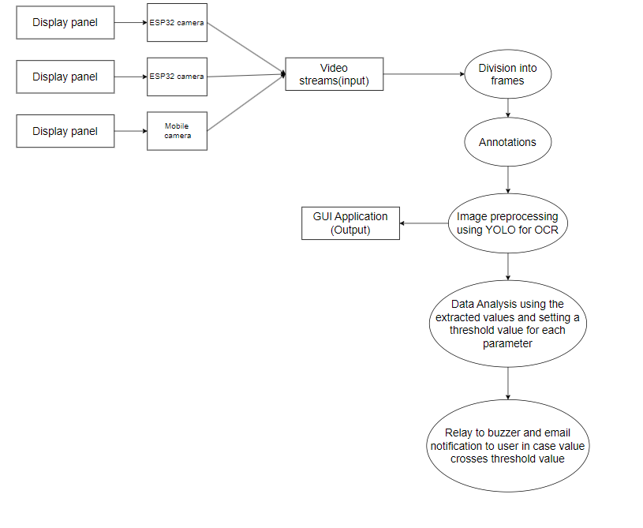

**Fig 1: Block diagram of the Proposed system for live video streaming**

**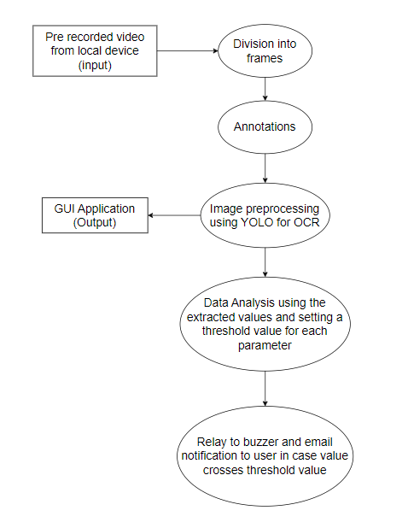  
Fig 2: Block diagram of the Proposed system for pre recorded video**

The image shows a flow diagram of the process of extracting data from a machine display panel using ESP32 and YOLO in Linux. The stages of the process are as follows:

1. Capture image: The ESP32 captures an image of the machine display panel.
2. Preprocess image: The image is preprocessed to improve the accuracy of the YOLO object detection model. This may involve resizing the image, converting the image to grayscale, or normalizing the image.
3. Detecting objects: The YOLO object detection model is used to detect objects in the image. The model outputs a list of detected objects, along with their bounding boxes and confidence scores.
4. Extract data: Data is extracted from the detected objects. This may involve extracting the type of object, the size of the object, or the location of the object in the image.
5. Save data: The extracted data is saved to a file or sent to a server.

The flow diagram also shows a decision block after the "Detecting objects" stage. This block is used to determine whether any objects were detected in the image. If no objects are detected, the system may repeat the "Capture image" stage.

The video frames extracted by the processing models are fed to the yolo model .The yolo model is used for performing training and testing on the data . After this the data recognition occurs and we can see the results.

**4.2. Modular diagram of the system:**

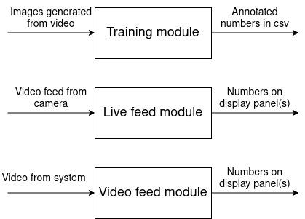

**Fig 3: Modular Diagram**

The following steps take place in the model

1. The images generated from video are trained and the output is the annotated numbers in a csv format
2. The live video feed is used for displaying real time data
3. The video from the system is processed to show the numbers on the display panel

**4.3. Project Scheduling & Tracking using Time line / Gantt Chart:**

The Gantt chart of our project where we worked for the whole semester to create this model is shown in a timeline pattern. It is the most important part to think and design the planning of your topic and so we planned our work like the gantt chart shown.

| **Task** | **Start Date** | **Finish Date** | **Members** |
| --- | --- | --- | --- |
| Meeting and work started on the previous implementation | 14-08-2023 | 18-08-2023 | Prathamesh, Shreyas, Hariharan, Tanisha |
| Meeting with the seniors to discuss previous implementation and work on hardware | 21-08-2023 | 28-08-2023 | Prathamesh, Shreyas, Hariharan, Tanisha |
| Shifting of the project to Ubuntu and implementing hardware | 28-08-2023 | 01-09-2023 | Prathamesh, Shreyas, Hariharan, Tanisha |
| Buy new hardware and update hardware libraries | 04-09-2023 | 08-09-2023 | Prathamesh, Shreyas, Hariharan, Tanisha |
| Meet with mentors regarding next work | 11-09-2023 | 18-09-2023 | Prathamesh, Shreyas, Hariharan, Tanisha |
| Prepare ppt and record video | 18-09-2023 | 22-09-2023 | Prathamesh, Shreyas, Hariharan, Tanisha |
| Show the current implementation and understand the future work | 25-09-2023 | 02-10-2023 | Prathamesh, Shreyas, Hariharan, Tanisha |
| Finish the work for the semester | 02-10-2023 | 11-10-2023 | Prathamesh, Shreyas, Hariharan, Tanisha |
| Start analyzing the extracted data | 20-11-2023 | 27-11-2023 | Prathamesh, Shreyas, Hariharan, Tanisha |
| Started work on scalability, tested working with multiple cameras | 27-11-2023 | 05-12-2023 | Prathamesh, Shreyas, Hariharan, Tanisha |
| Started working with new ESP32 cameras and mobiles | 04-12-2023 | 14-12-2023 | Prathamesh, Shreyas, Hariharan, Tanisha |
| Created presentation on recent updates in the project and made video | 15-01-2024 | 19-01-2024 | Prathamesh, Shreyas, Hariharan, Tanisha |
| Made changes in codebase to implement email extraction | 22-01-2024 | 26-01-2024 | Prathamesh, Shreyas, Hariharan, Tanisha |
| Started implementation on buzzer code | 29-01-2024 | 02-02-2024 | Prathamesh, Shreyas, Hariharan, Tanisha |
| Worked on the buzzer code and email sending | 12-02-2024 | 23-02-2024 | Prathamesh, Shreyas, Hariharan, Tanisha |
| Finished implementing email sending facility and buzzer | 04-03-2024 | 15-03-2024 | Prathamesh, Shreyas, Hariharan, Tanisha |
| Attempted to implement remote streaming of the video feed | 18-03-2024 | 29-03-2024 | Prathamesh, Shreyas, Hariharan, Tanisha |
| Finished tasks for the semester | 01-04-2024 | 02-04-2024 | Prathamesh, Shreyas, Hariharan, Tanisha |

Table 2. Workflow table

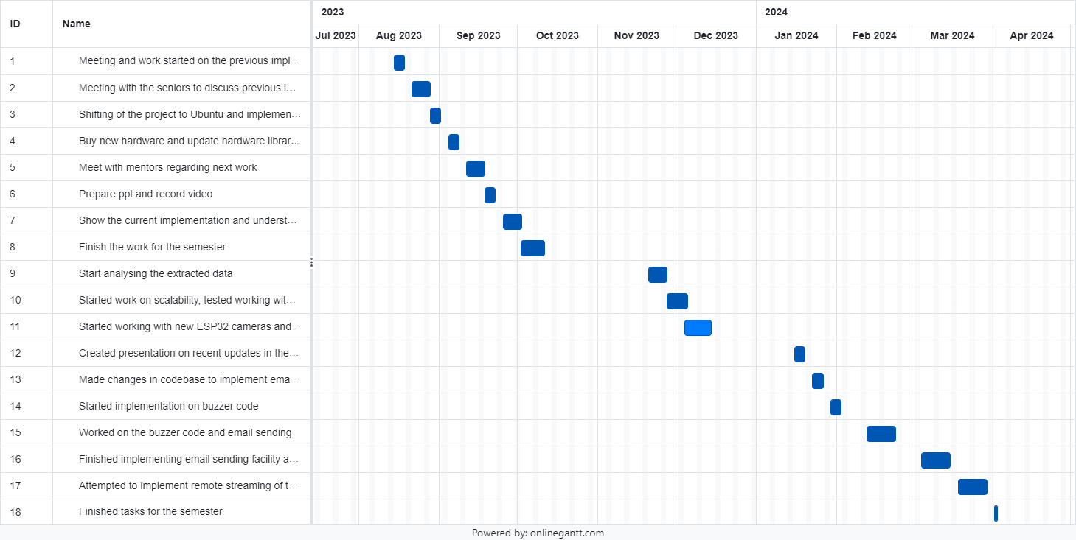

**Fig 4 : Gantt chart**

**Chapter 5: Implementation of the Proposed System**

**5.1.Methodology employed for development:**

1. Different cameras like ESP 32 camera can be used but the functionality can be extended and even mobile cameras can be used so the entire model is scalable .
2. The camera is pointed towards the display panel.
3. Divide the video into frames and annotate the model using makesense.ai tool.
4. Divide the annotated files into training and validation datasets.
5. Train the YOLO model on the training images.
6. For testing, live camera feed can be used or a video from the local file system can also be uploaded.
7. Post training and testing the next part involves a trigger system i.e. alarm system which will observe and initiate an alarm in case the value crosses a particular threshold.
8. An email alert system has also been incorporated which will send an email to the supervisor in case a predefined threshold is breached.

**Chapter 6: TESTING OF THE PROPOSED SYSTEM**

**6.1 Introduction to testing**

The proposed system for the project includes various software as well as hardware components. Testing was required to test each hardware component and to make sure that the software worked on multiple devices efficiently and correctly.

**6.2 Types of tests considered**

**Unit tests:**

We considered working on the application on the Ubuntu operating system and the working of the ESP-32 camera for the same.

Application on Ubuntu operating system:

We shifted the application code from Windows to Ubuntu. First, we checked whether the video was being uploaded to the application directly. But, the application was not displaying the video files in the file explorer. For this, we had to make changes to the uploading function in the codebase so that the file would be uploaded properly.

ESP32 camera:

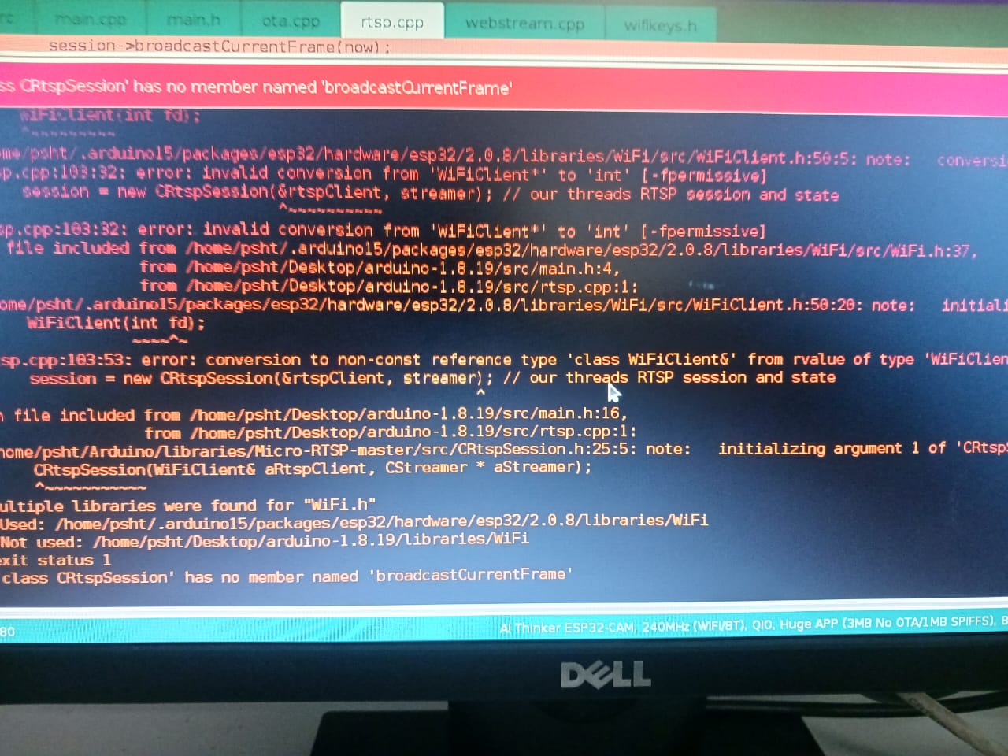

**Fig 5: Error on Arduino**

This was an error due to the outdated library which was in use during testing of the ESP32 camera. We had to find the most recent version of the hardware library which enabled the use of the camera.

**Integration testing:**

Next, we integrated the working of the application along with the hardware. No errors occurred in this phase and the application worked seamlessly. We also checked the working of the alarm and the email facility which was newly added. We had to make changes to the login page in order for the email to go through.

**System testing:**

Next, we checked the working of the application on different devices. The application was tested on 5 different devices and there were no issues.

**Acceptance testing:**

Lastly, we checked the working of the application end to end. All implemented functionalities worked seamlessly.

**6.3 Test scenarios considered**

* Uploading a video from the local system

The application provides a facility of uploading a previously recorded video of the display panel to detect the numbers. After shifting the application from Windows to Ubuntu, we checked whether the mp4 files were being detected for uploading the video.

* Accessing a stream from an ESP32 camera

For live streaming, we used the ESP32 camera. After uploading the relevant code to the camera, a rtsp link would be generated which, once accessed, would enable us to view the stream on any compatible device. We checked whether the application was able to access the stream using various different cameras.

* Exceeding of threshold value

We had included a clause in the code, where if the number of the panel exceeded a certain value, an alarm would sound and an email notification would be sent to the logged in email id. We tested this using a pre-recorded video and live stream.

* Multiple cameras within a single network

For scalability purposes, we used more than 2 cameras at a time within the application to check if all streams were visible and properly accessed.

**6.4 Inference drawn from the test cases**

The inference drawn was that the application can work seamlessly on Windows and Ubuntu operating systems, with changes in code required on change in OS. Also, the hardware libraries need to be constantly checked for updates.

**Chapter 7: RESULTS AND DISCUSSION**

The results generated from the model will help the industries under consideration to carry on smooth functionality without manually changing any circuits , it will also help them to update their systems without having to worry about the data capture as the system is externally controlled. The risk of not noticing errors will be less as the system has built in triggers which will set off an alarm.

The hardware setup includes an esp32 cam mounted on an esp32 module which will enable it to be connected through usb. The cam can be connected to an independent power source through usual micro usb cable. For setting up a new cam, the code needs to be uploaded into the module through arduino. Later on, it only needs power to function.

**7.1.Screenshot of Use Interface(UI) for the system:**

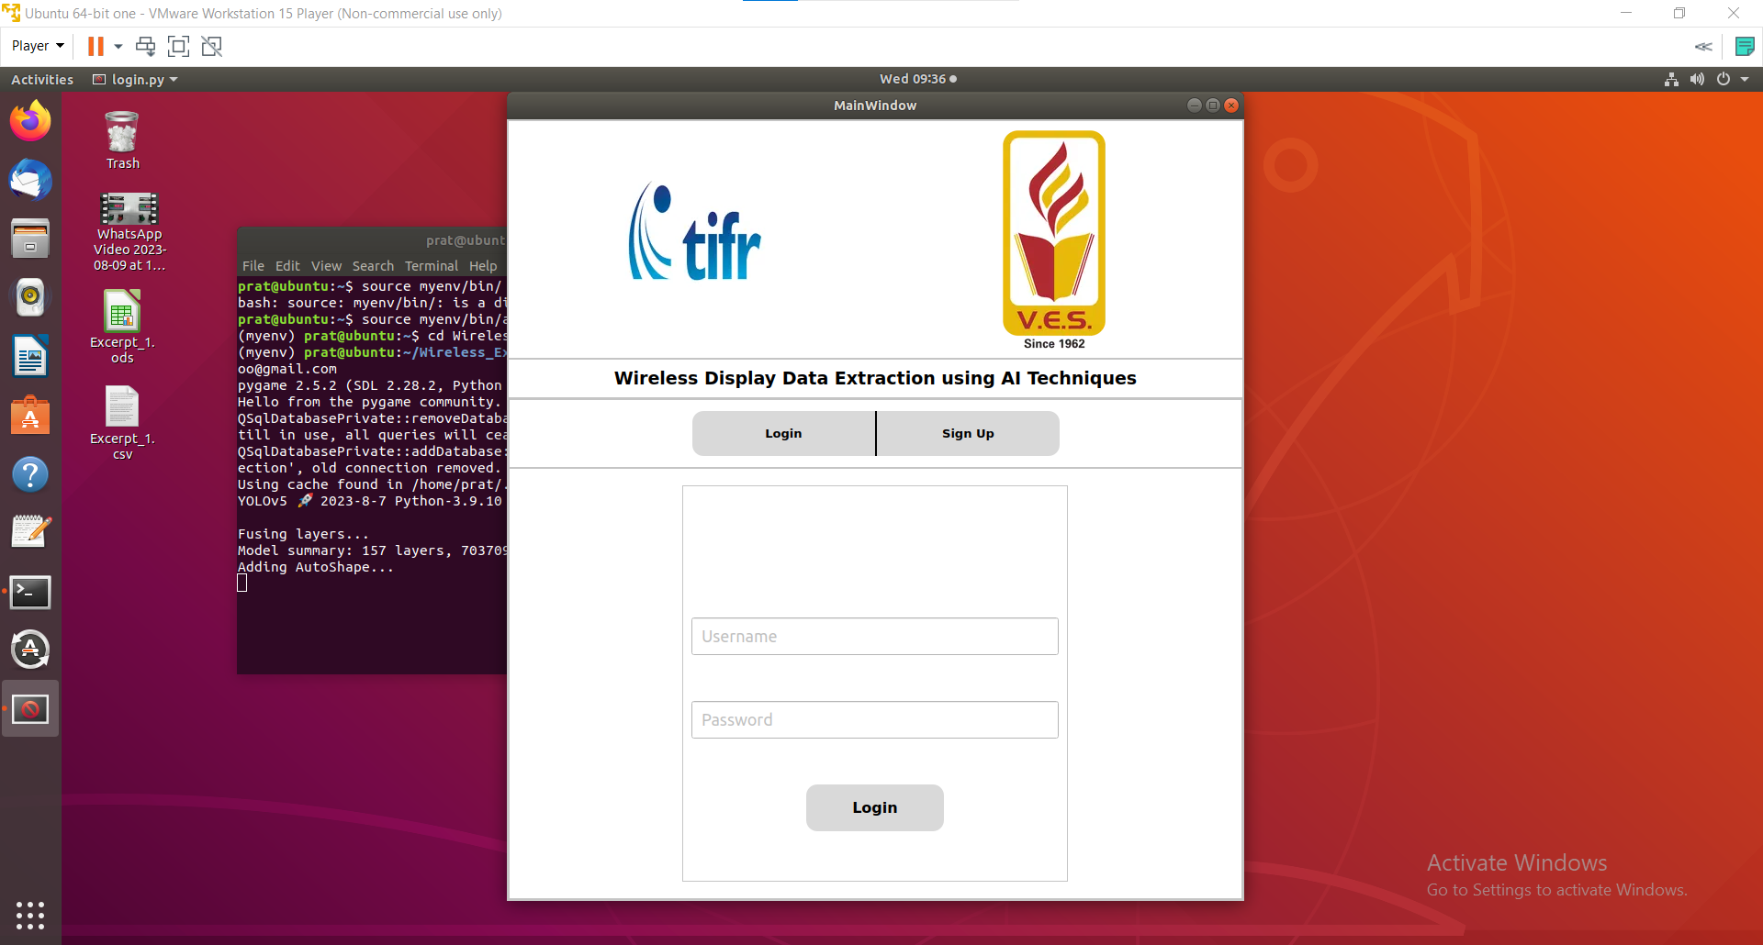**Fig 6: Screenshot for Login page**

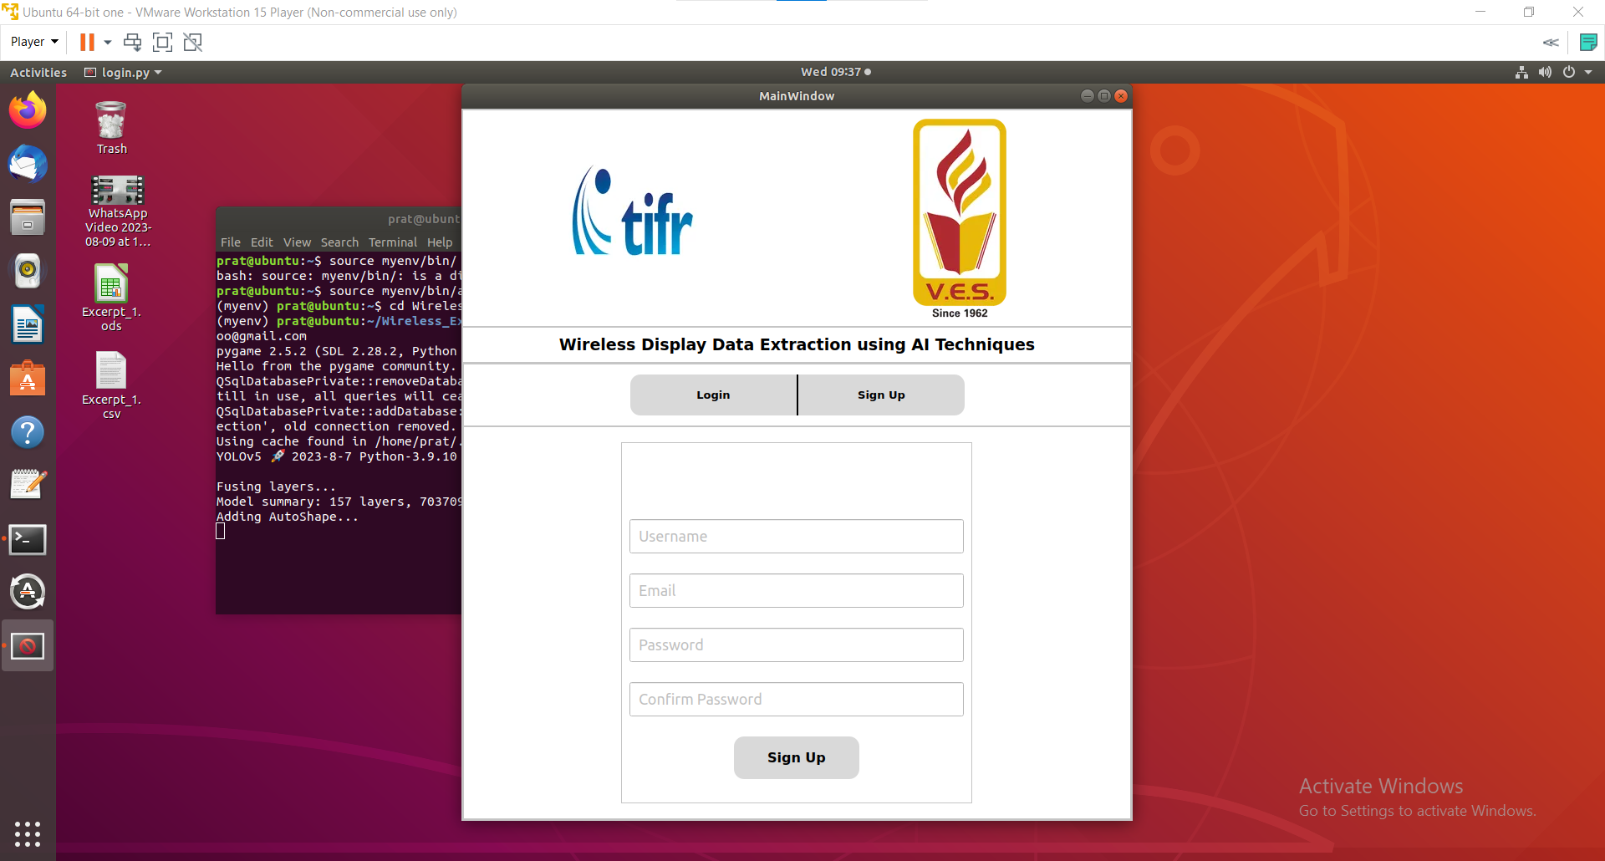**Fig 7: Screenshot for Register page**

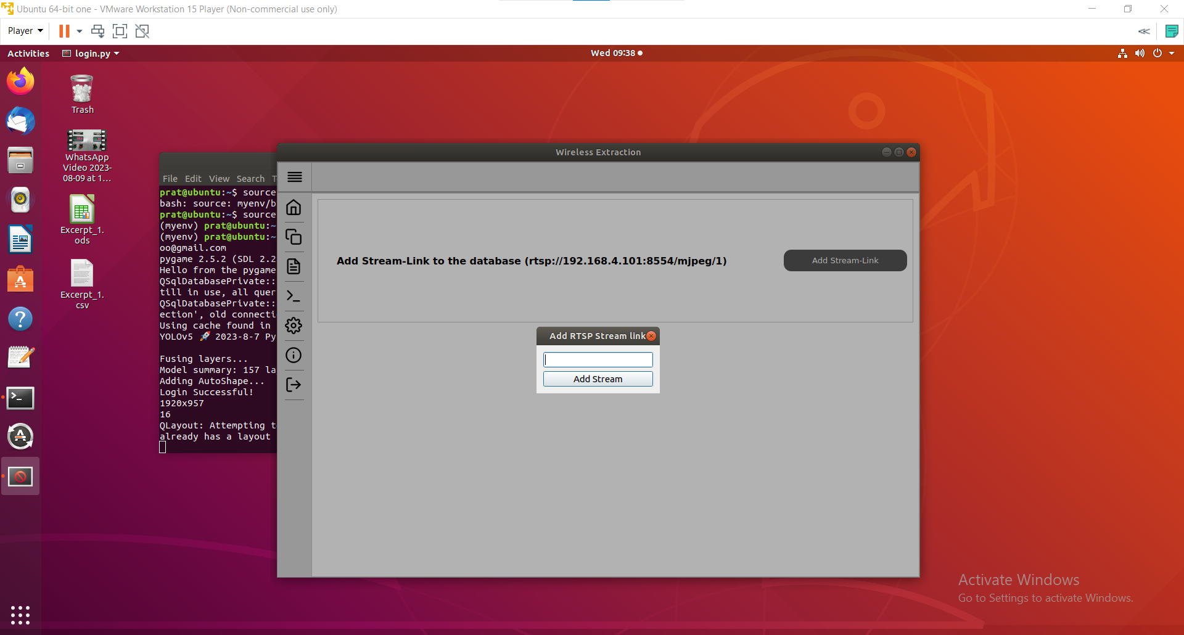**Fig 8: Enter a new RTSP ( real time streaming protocol) link**

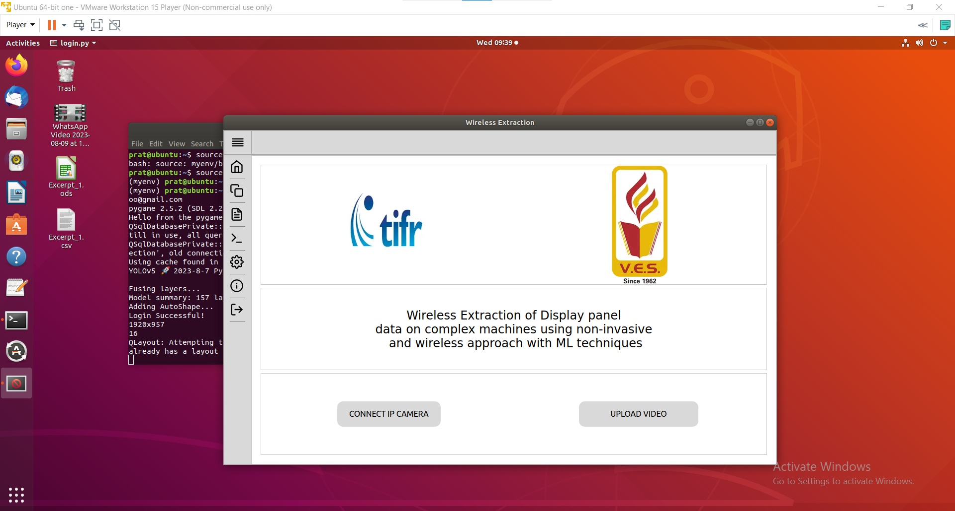**Fig 9: Home page where user can upload a video from local system or connect to an existing ip camera link**

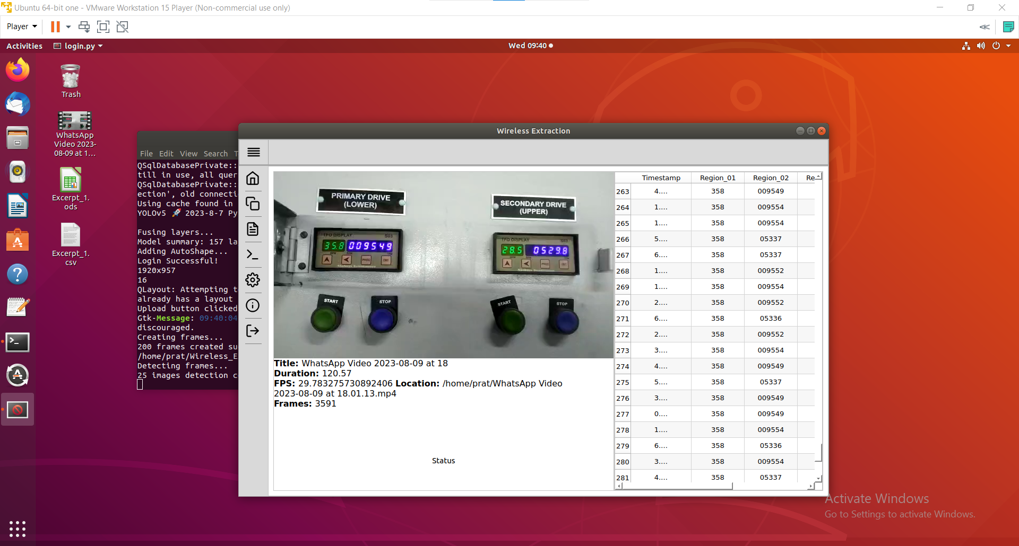**Fig 10: Detecting numbers**

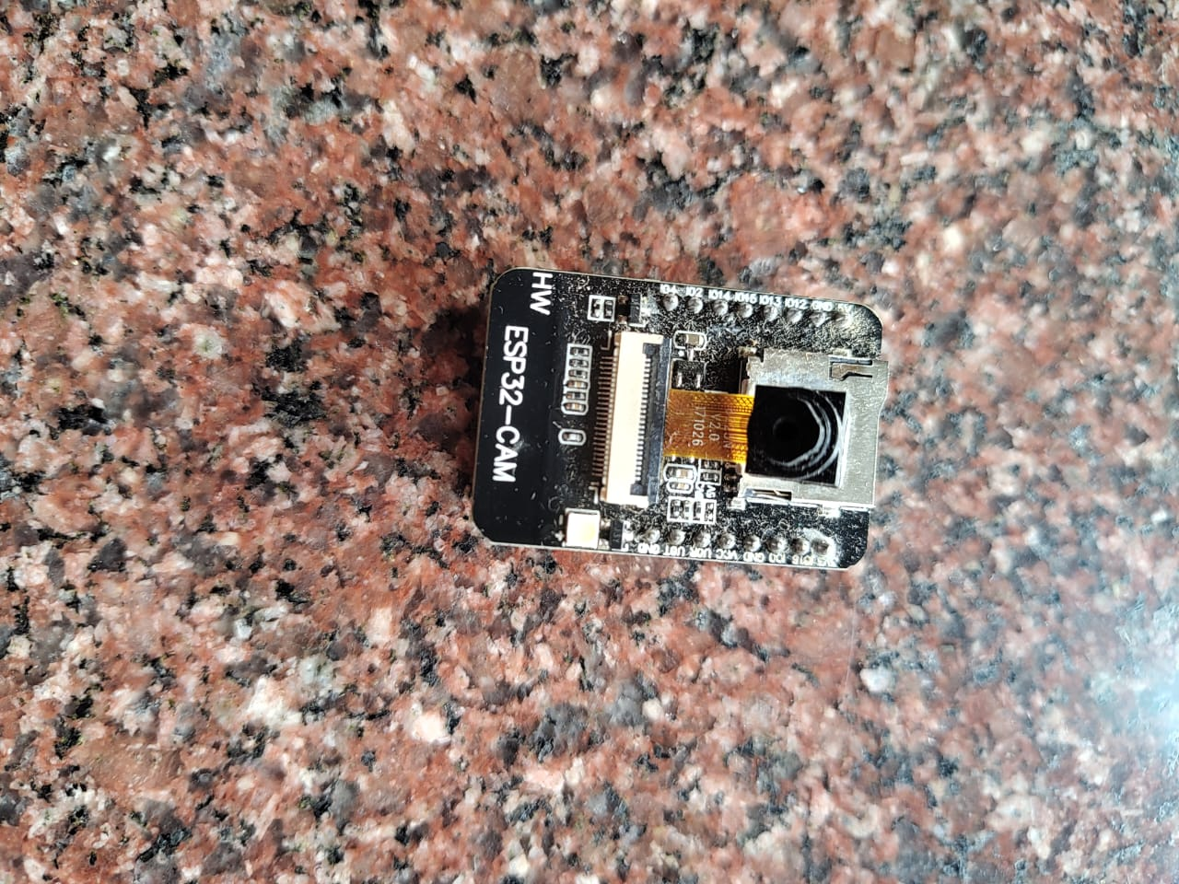

**Fig 11: ESP32 CAM Module**

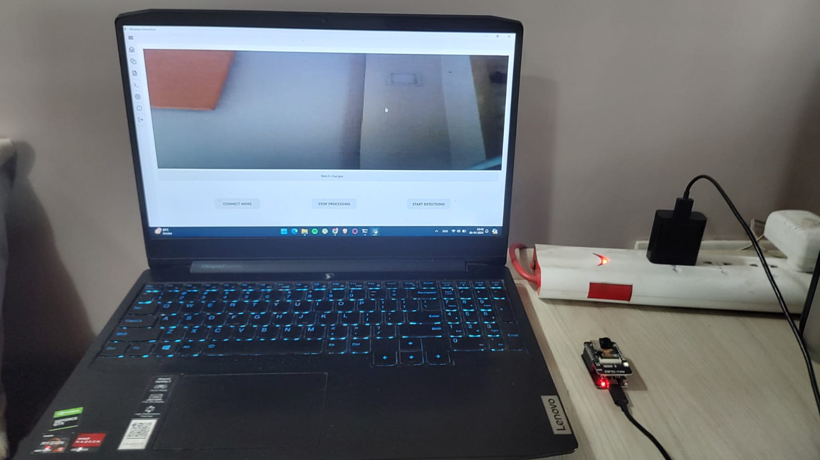

**Fig 12: Hardware Setup**

**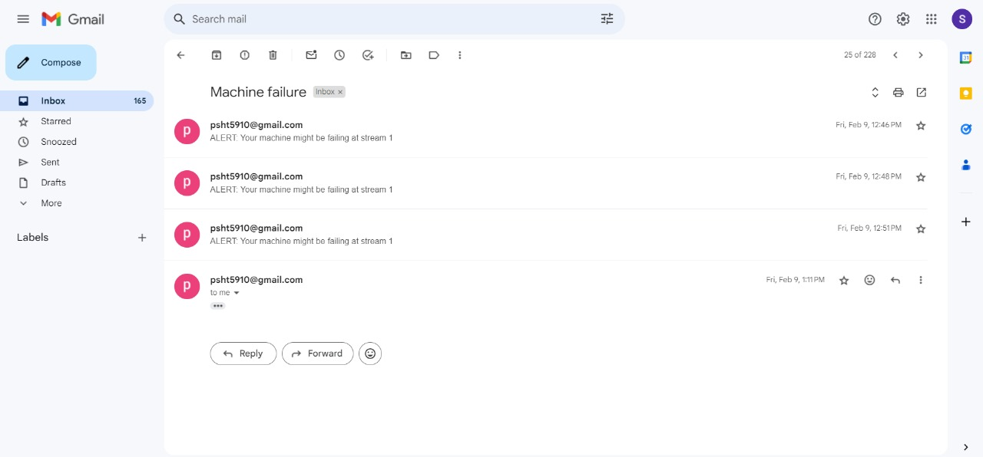  
Fig 13: Email notification sent to the logged in email on a value beyond set threshold**

**7.2. Performance Evaluation Measures:**

The application works on accessing data from the display panels using the YOLO model.

* The accuracy of the model in detecting the numbers
* How accessible the extracted data is
* How user friendly the application interface is

**Chapter 8: Conclusion**

**8.1.Limitations:**

* Any remote stream cannot be accessed by the application
* The model is not 100% accurate
* The video feed of the ESP32 camera can sometimes be unclear

**8.2.Conclusion:**

The suggested system is a low-cost, easy-to-implement, non-invasive, and accurate and reliable system to extract data from machine display panels utilizing ESP32 and YOLO under Linux. The system has the potential to boost effectiveness, productivity, and quality in a number of industries.

Although the suggested system is still under development, it has the potential to completely alter how data is gathered and utilized in a number of different businesses.

**8.3. Future Scope:**The future scope of the project can include remote streaming of the video feeds and their capture by the application. This can be achieved through the port forwarding mechanism, which requires a public server, meaning an ip address which can be accessed remotely. Any request on that public ip address will internally be forwarded to the ip address on which the stream is available.

**References**

1. Gubbi, Jayavardhana et al. "A Survey on Internet of Things (IoT) Technologies for Smart Cities." IEEE Communications Surveys & Tutorials, vol. 15, no. 4, 2013, pp. 1679-1710.
2. Redmon, Joseph et al. "You Only Look Once: Unified, Real-Time Object Detection." Proceedings of the IEEE Conference on Computer Vision and Pattern Recognition (CVPR), 2016, pp. 779-788.
3. Singh, Amit Pratap et al. "IoT-based Smart Parking System using YOLO Object Detection." International Journal of Computer Applications, vol. 180, no. 26, 2018, pp. 6-9.
4. Acharya, Sasmita et al. "Smart Healthcare Monitoring System using IoT and Deep Learning Techniques." Journal of Ambient Intelligence and Humanized Computing, vol. 11, no. 3, 2020, pp. 1161-1172.
5. Zainal, Nurul Hidayah Binti et al. "Internet of Things (IoT) and Artificial Intelligence (AI) Integration for Industrial Applications: A Review." MATEC Web of Conferences, vol. 268, 2019, 06007.
6. Coccoli, Lorenzo et al. "YOLO-based Object Detection and Recognition System for Industrial Automation." Procedia Manufacturing, vol. 38, 2019, pp. 1570-1575.
7. A. Botta, W. De Donato, V. Persico, and A. Pescapé, "Integration of Cloud Computing and Internet of Things: A Survey," in Proceedings of IEEE, 2016
8. H. Ren, L. Fan, X. Cui, et al., "An Edge Computing-Based Data Acquisition Approach for Wireless Sensor Networks in IoT," in Proceedings of IEEE, 2019.
9. A. Kaur and G. Singh, "Machine Learning Techniques for IoT Data Analytics: A Review," in Proceedings of IEEE, 2020.
10. Singh, Kiran Jot, et al. "Computer-Vision Based Object Detection and Recognition for Service Robot in Indoor Environment." Computers, Materials & Continua 72.1 (2022).
11. Liu, Jiang, et al. "Deep learning for image identification: A review." arXiv preprint arXiv:1904.11851 (2019).
12. Majiwar, Gaurav, et al. "A survey on image identification using deep learning." International Journal of Computer Applications 147.14 (2016): 34-42.
13. Miao, Yu, et al. "A deep learning-based approach for image identification and segmentation." IEEE Transactions on Circuits and Systems for Video Technology 28.8 (2017): 1908-1921.
14. Zhu, Xingang, et al. "Deep learning for image identification: A comprehensive review." Frontiers in Computer Science 11 (2017): 507-526.
15. Yang, Yunchao, et al. "A survey on deep learning for image identification and classification." ACM Computing Surveys (CSUR) 52.6 (2020): 1-41.
16. Redmon, Joseph, and Ali Farhadi. "YOLO9000: Better, faster, stronger." arXiv preprint arXiv:1612.08242 (2016).
17. Redmon, Joseph, and Ali Farhadi. "YOLOv3: An incremental improvement." arXiv preprint arXiv:1804.02767 (2018).
18. Jocher, Glenn, et al. "YOLOv4: Optimal speed and accuracy of object detection." arXiv preprint arXiv:2004.10934 (2020).
19. Wang, Qiang, et al. "YOLOv5: An efficient and accurate object detection architecture." arXiv preprint arXiv:2004.10934 (2020).
20. Wang, Yao, et al. "YOLOv6: Next-generation object detection with improved performance and generalization." arXiv preprint arXiv:2104.10034 (2021).
21. Espressif Systems. ESP32 Datasheet. Espressif Systems, 2020.
22. Espressif Systems. ESP-IDF Programming Guide. Espressif Systems, 2020.
23. Espressif Systems. ESP-CAM Datasheet. Espressif Systems, 2020.
24. Espressif Systems. ESP-EYE Datasheet. Espressif Systems, 2020.
25. Espressif Systems. ESP-WROVER-KIT Datasheet. Espressif Systems, 2020.
26. Singh, Amit Pratap, et al. "IoT-based Smart Parking System using YOLO Object Detection." International Journal of Computer Applications 180.26 (2018): 6-9.
27. Acharya, Sasmita, et al. "Smart Healthcare Monitoring System using IoT and Deep Learning Techniques." Journal of Ambient Intelligence and Humanized Computing 11.3 (2020): 1161-1172.
28. Zainal, Nurul Hidayah Binti, et al. "Internet of Things (IoT) and Artificial Intelligence (AI) Integration for Industrial Applications: A Review." MATEC Web of Conferences 268 (2019): 06007.
29. Coccoli, Lorenzo, et al. "YOLO-based Object Detection and Recognition System for Industrial Automation." Procedia Manufacturing 38 (2019): 1570-1575.
30. A. Botta, W. De Donato, V. Persico, and A. Pescapé, "Integration of Cloud Computing and Internet of Things: A Survey," in Proceedings of IEEE, 2016.
31. H. Ren, L. Fan, X. Cui, et al., "An Edge Computing-Based Data Acquisition Approach for Wireless Sensor Networks in IoT," in Proceedings of IEEE, 2019.
32. A. Kaur and G. Singh, "Machine Learning Techniques for IoT Data Analytics: A Review," in Proceedings of IEEE, 2020.

**Appendix**

**Project review sheet ;**

**Project review sheet 1:**

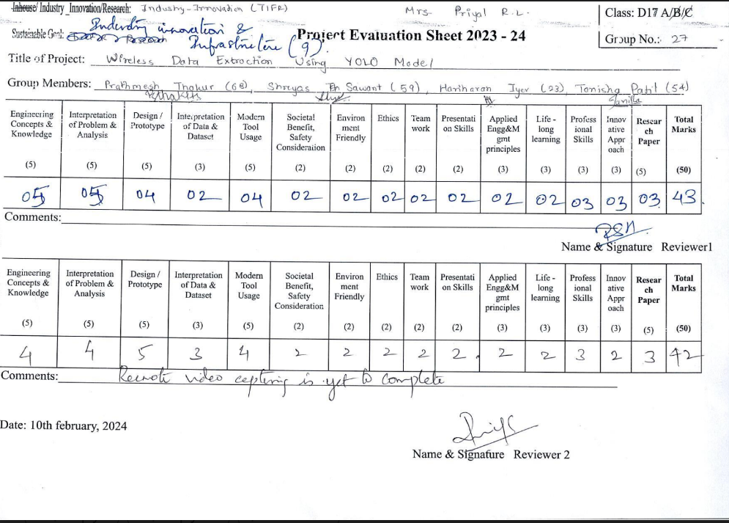

**Project review sheet 2**

